# 



Immersion Day

S3 Hands-On Lab

Getting Started with Simple Storage Service

# Amazon S3 Overview

Amazon Simple Storage Service (S3) provides a simple web services interface that can be used to store and retrieve any amount of data, at any time, from anywhere on the web. This lab is designed to demonstrate how to interact with S3 to store, view, move and delete objects.

This lab will walk you through the following:

* Creating a bucket in S3
* Adding an object to the S3 bucket
* View the object in S3
* Move the object in S3
* Enable bucket versioning
* Delete the object and the bucket in S3

# Create a Bucket in S3

To upload your data (photos, videos, documents etc.) to Amazon S3, you must first create an S3 bucket in one of the AWS Regions. You can then upload your data objects to the bucket. Every object you store in Amazon S3 resides in a bucket. You can use buckets to group related objects in the same way that you use a directory to group files in a file system.

***Note:*** *You are not charged for creating a bucket; you are only charged for storing objects in the bucket and for transferring objects in and out of the bucket.*

***Note:*** Transfer IN does not incur a charge, but Transfer OUT does. Data transfers are free if you are within the same region and within the same availability zone, and use a private IP address. Data transfers to other regions or services will have a cost associated with them. See <https://aws.amazon.com/s3/pricing/> for more details.

1. Sign into the AWS Management Console and open the Amazon S3 console at <https://console.aws.amazon.com/s3>.
2. 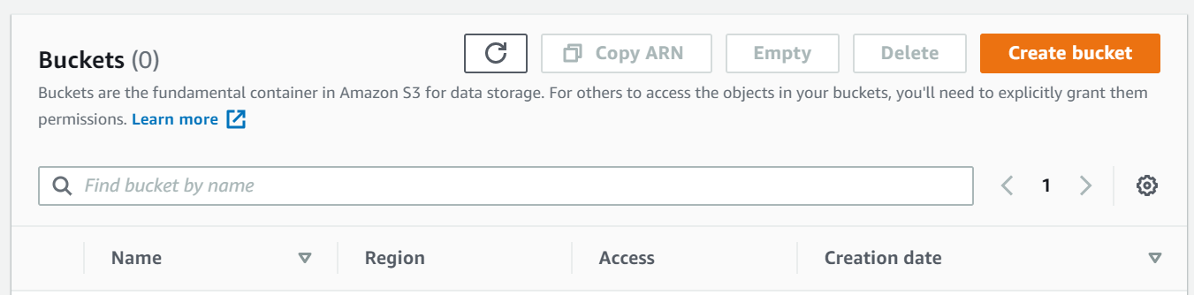Click **Create Bucket**. The **Create a Bucket** wizard will open.

**Note:** Enter a bucket name in the Bucket Name field. Since S3 is a global service, the bucket name you choose must be unique across all existing bucket names in Amazon S3. One way to do that is to prefix your bucket names with your organization's name.

Bucket names must comply with the following requirements. The bucket name:

* Must be unique across all of Amazon S3
* Must be between 3 and 63 characters long
* Must not contain uppercase characters
* Can contain only lower-case characters, numbers, periods, and dashes
* Must Start with a lowercase letter or number
* Must Not contain underscores, end with a dash, have consecutive periods, or use dashes adjacent to periods.
* Cannot be formatted as an IP address ([198.51.100.24](http://198.51.100.24/)).

**Note:** There might be additional restrictions on bucket names based on the region your bucket is in or how you intend to access the object. Once you create a bucket, you cannot change its name. In addition, the bucket name is visible in the URL that points to the objects stored in the bucket. Make sure the bucket name you choose is appropriate.

1. In the **Region** drop-down list box, select a region. Choose a Region close to you to minimize latency and costs and address regulatory requirements. Objects stored in a Region never leave that Region unless you explicitly transfer them to another Region

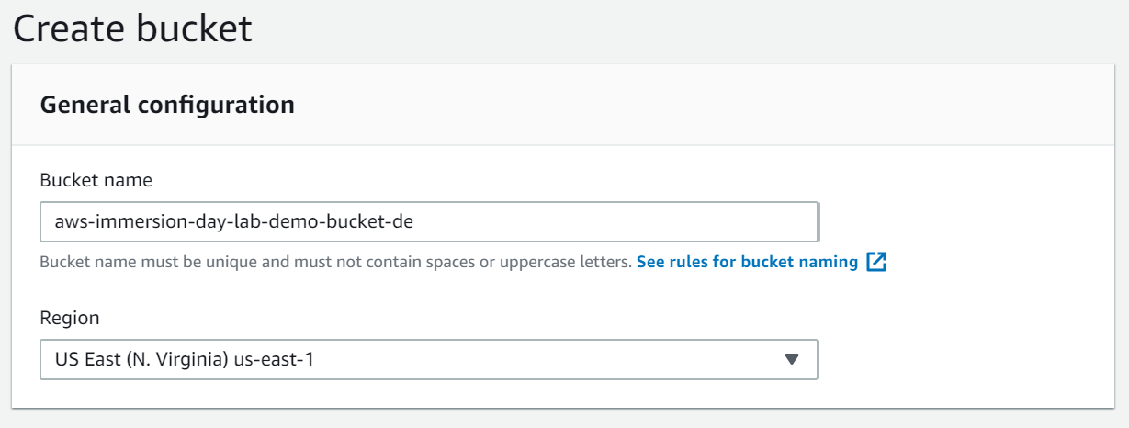

1. By default, all buckets are set to “block public access”. At this time, leave the default setting of block all public access. [Learn More](https://docs.aws.amazon.com/AmazonS3/latest/user-guide/block-public-access.html)
2. Under Advanced settings, you have the option to enable Object Lock. Object Lock stores objects using a write-once-read-many (WORM) model to prevent objects from being deleted or overwritten for a fixed amount of time or indefinitely. For today’s lab, we will leave this disabled. [Learn More](https://docs.aws.amazon.com/AmazonS3/latest/dev/object-lock.html)
3. Click Create Bucket to create your bucket.

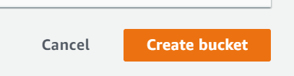

1. Once your bucket is created, you will be able to see it in your Buckets list. You can also see the region your bucket is in along with the access type.

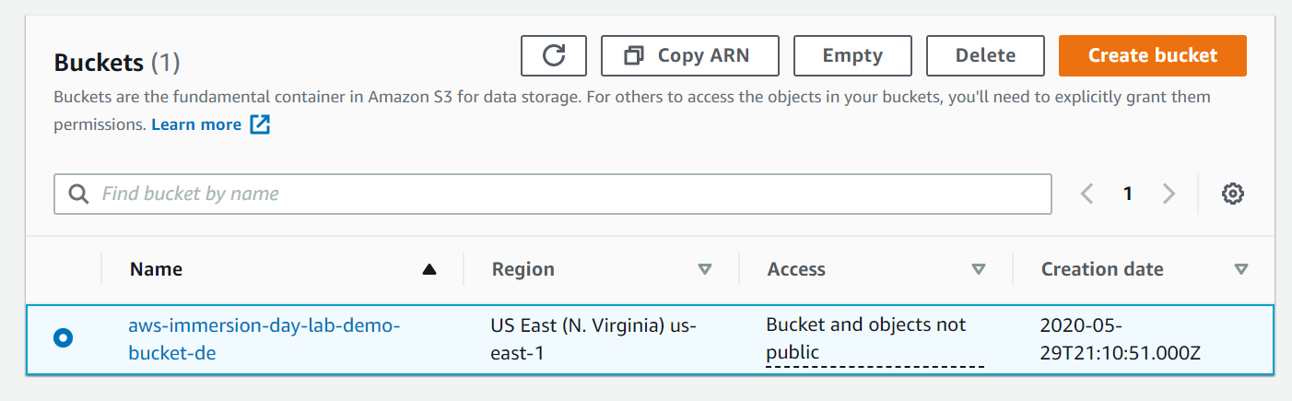

**Well done – you have created your first bucket in Amazon S3!**

# Add an Object to a Bucket

Now that you have created a bucket, you are ready to add an object to it. An object can be any kind of file: a text file, a photo, a video and so forth. When you upload a file to Amazon S3, it is stored as an S3 object. Objects consist of the file data and metadata that describes the object. You can have an unlimited number of objects in a bucket. [Learn More](https://docs.aws.amazon.com/AmazonS3/latest/user-guide/upload-objects.html)

1. In the Amazon S3 console, click the on the name of the bucket that you want to upload your folders or files to. This should be the bucket you just created.
2. Choose Upload.

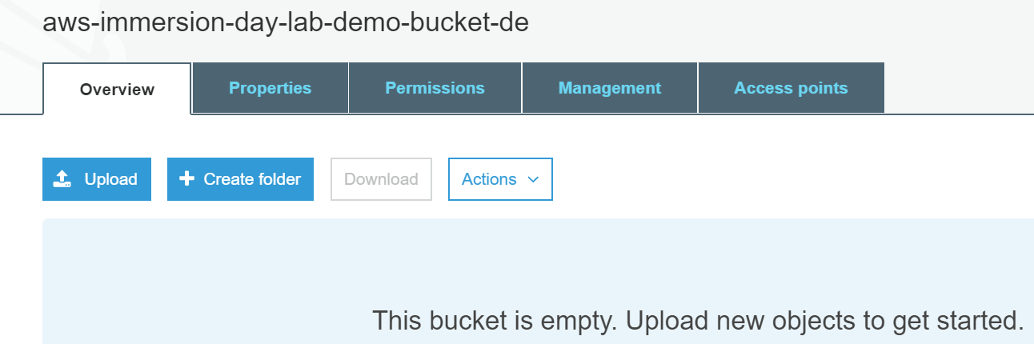

1. 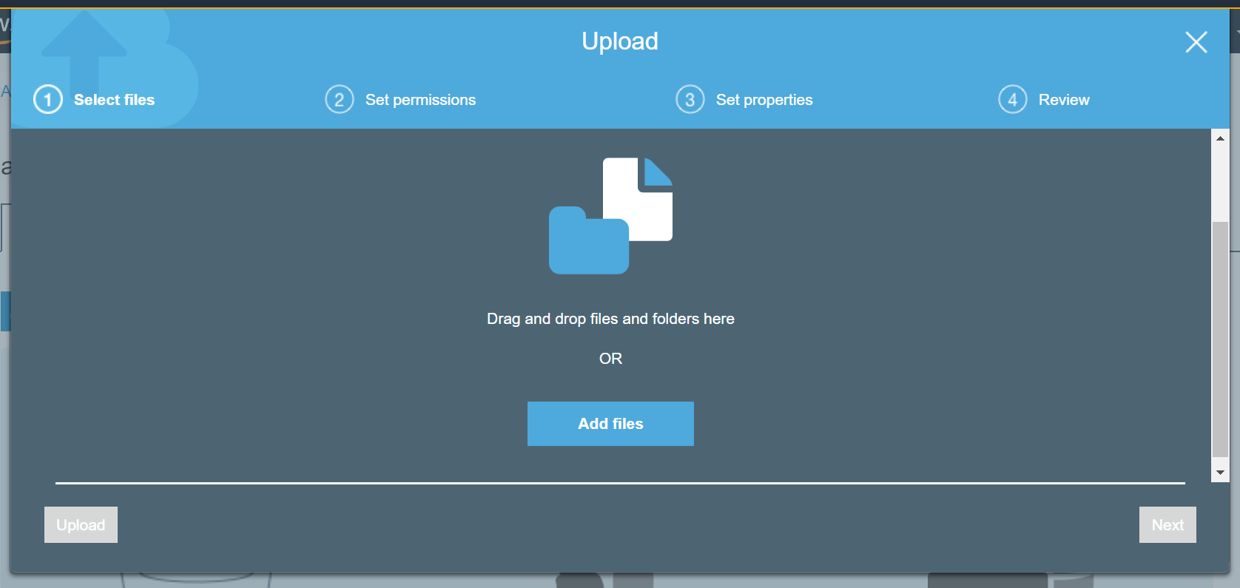In the Upload Dialog box, Choose Add Files. You may need to use the scroll bar on the right to scroll down to see the Add Files button.
2. 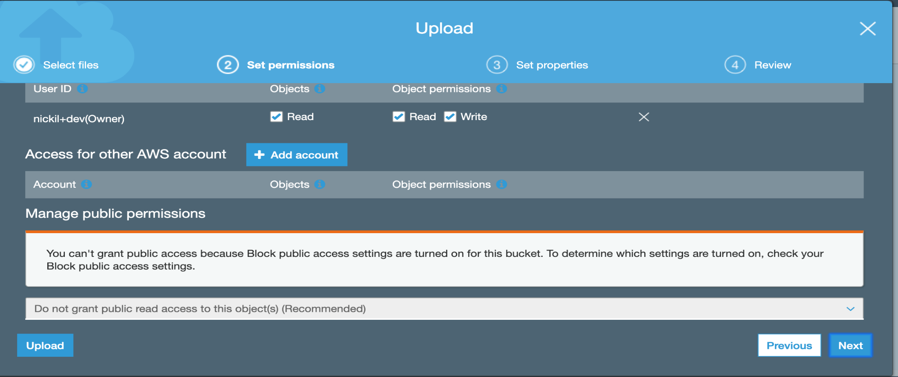Choose one of more files from your computer to add. For this lab, you can choose any file or picture you have available on you laptop. Click **Next three times** to set permissions or properties for the files that you are uploading. You can look at these to see what options are available. For today’s lab, we will use the default permissions. We will be using the standard storage option. To learn more about Amazon S3 storage classes [Click Here](https://aws.amazon.com/s3/storage-classes/)
3. Click Upload. You can watch the progress of the upload at the bottom of the screen.

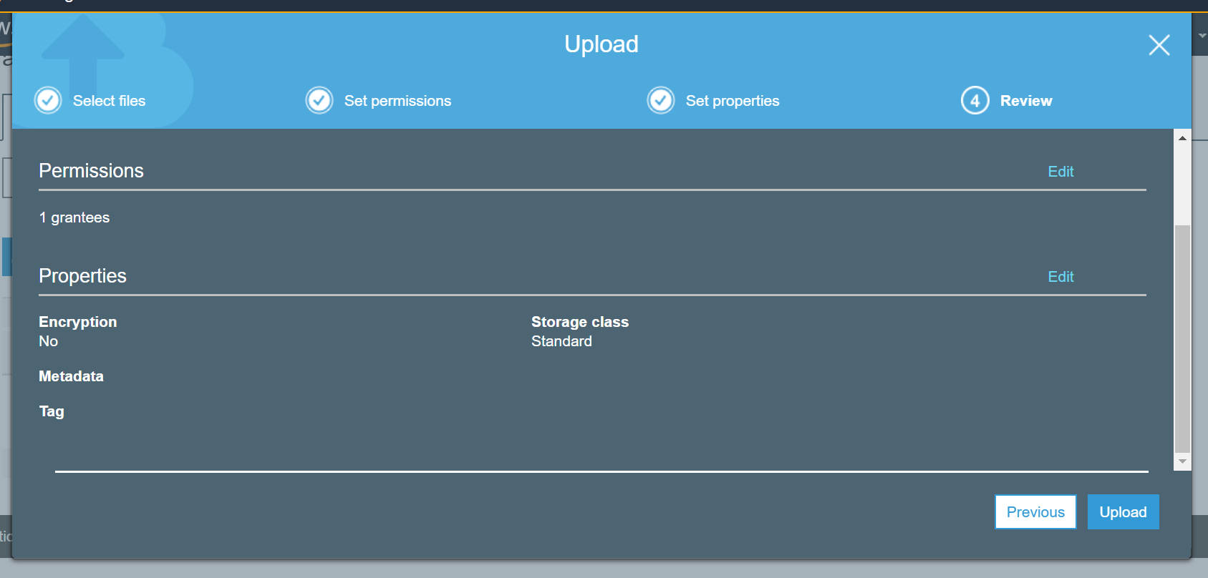

This bar appears as soon as the upload begins. Once the object has been uploaded, you will see a Success Message.



**Good work - you have added a file to your bucket!**

# View an Object

Now that you have added an object to a bucket, you can open and view it in a browser.

***Note****: By default, your Amazon S3 buckets and objects* ***are private****. To view an object using a URL, for example, https://s3.amazonaws.com/Bucket/Object the object must be publicly readable. Otherwise, you will need to create signed URL that includes a signature with authentication information.*

*Bucket access permissions* specify which users are allowed access to the objects in a bucket and which types of access they have. *Object access permissions* specify which users are allowed access to the object and which types of access they have. For example, one user might have only read permission, while another might have read and write permissions.

Bucket and object permissions are independent of each other.

1. 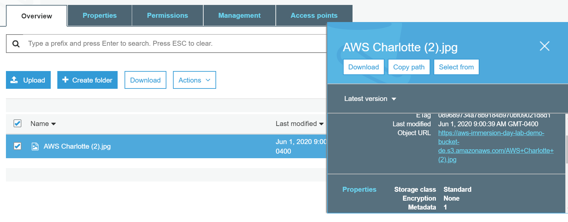Select the name of the file you uploaded. A pop up window will appear. Click on the object URL. You will receive an error message that access is denied. That is because our bucket and our object are blocked from public access.
2. 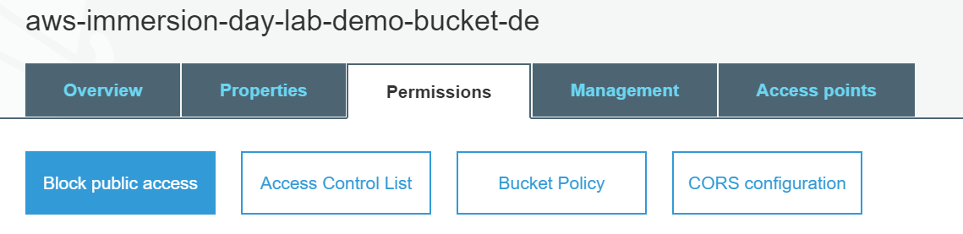Select the object, and then select Permissions.
3. 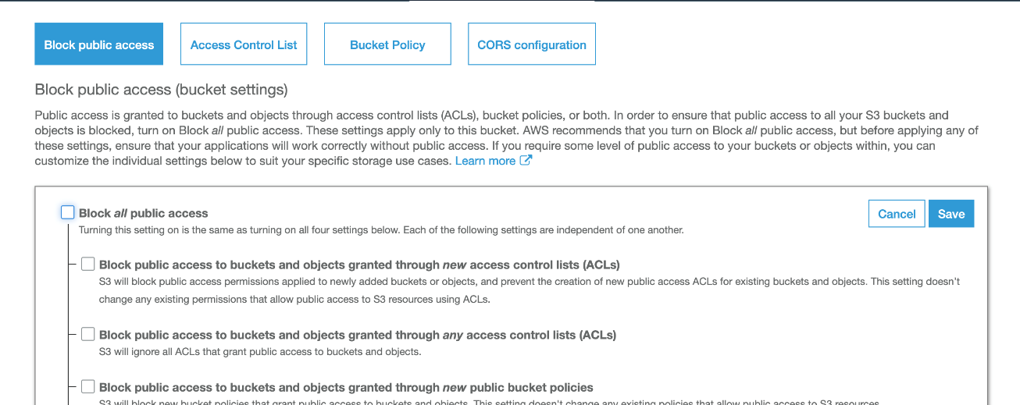Click Edit. Uncheck the box for Block all public access. Click **Save**.
4. Type “**confirm”** in the pop up window to confirm this change. You should see a message appears that states “Public access settings updated successfully”

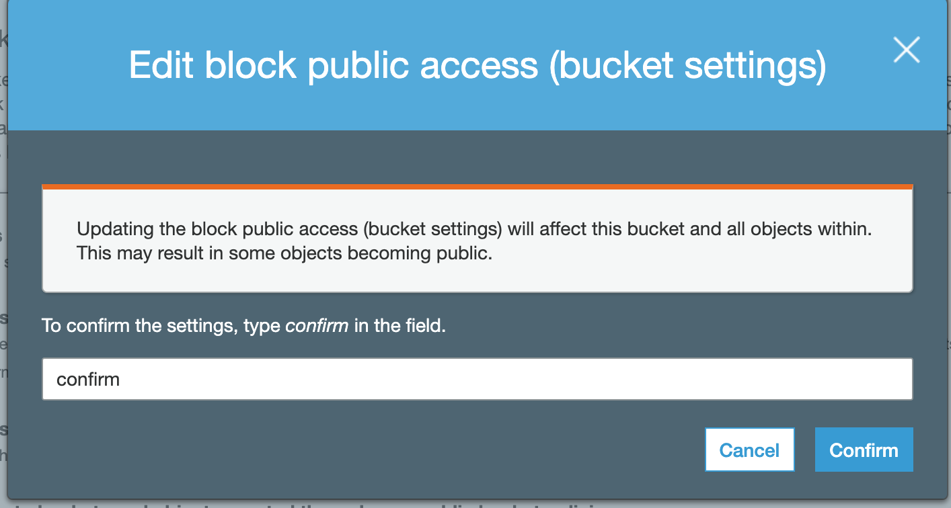

1. Go back to the object in your bucket. Check the box in front of your object. Click on overview. A pop up window appears on the left. Scroll down until you see Permission. Click on Permissions.

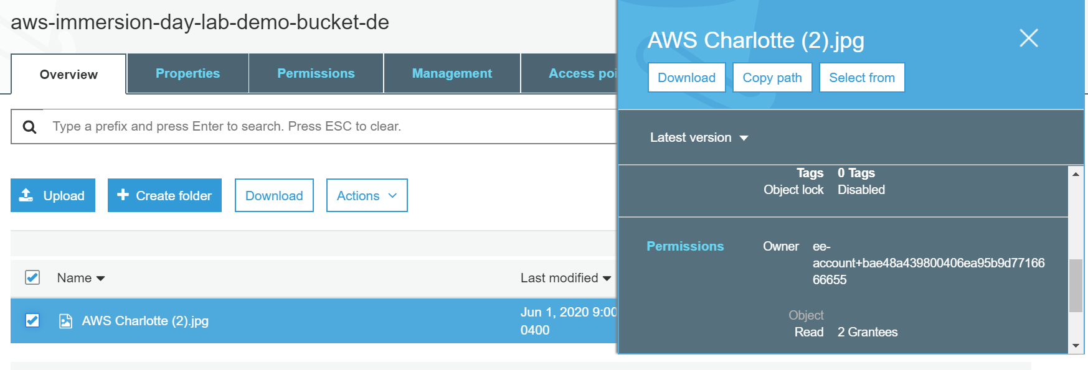

1. Scroll down and click on **Everyone** and **check** read object. You should see the following message pop up. Click **Save**.

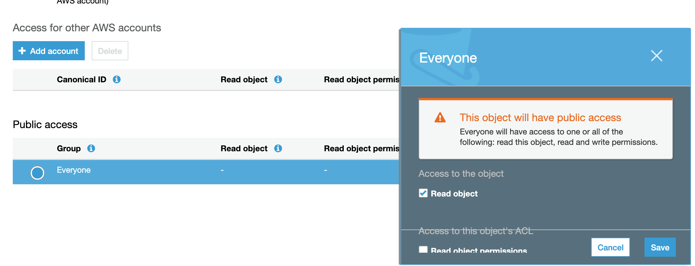

1. Click on the **Overview** tab. Scroll down and click on the Object URL. You should now be able to see your object.

**Good job – you have retrieved your object from S3 via the web!**

# Move an Object

Now that you have added an object to a bucket and viewed it, you might like to move the object to a different bucket or folder. In this example, we will use the **move** operation to move one or more objects from one bucket to another bucket.

1. In the Amazon S3 console, create another bucket. Follow the same instructions you did earlier.
2. Select the first bucket you created. Enable Block all public access. Follow the same instructions as earlier, instead this time, you will check the box to block all public access. Now the two buckets will have the same configuration.
3. Select the object(s) you want to move by clicking the selection box to their left. You can ignore the window that pops open when you select an object.
4. 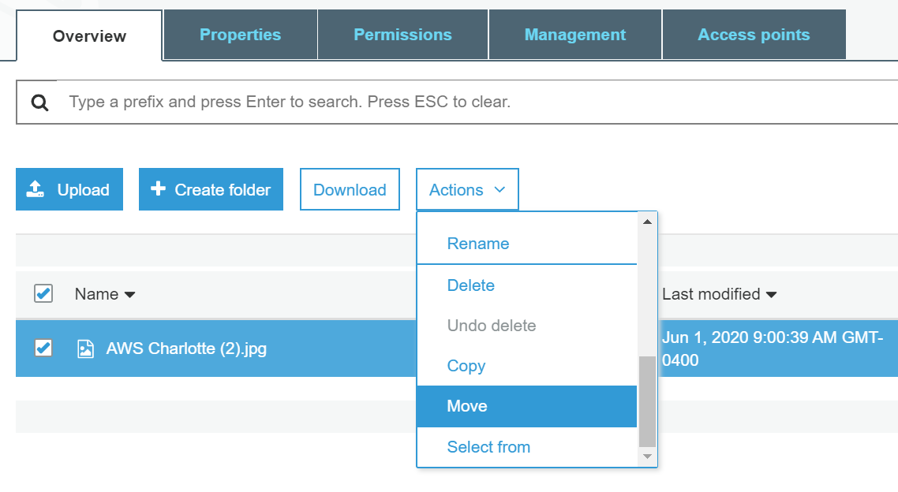Once you have selected your file, click on the Actions button, and then click Move
5. 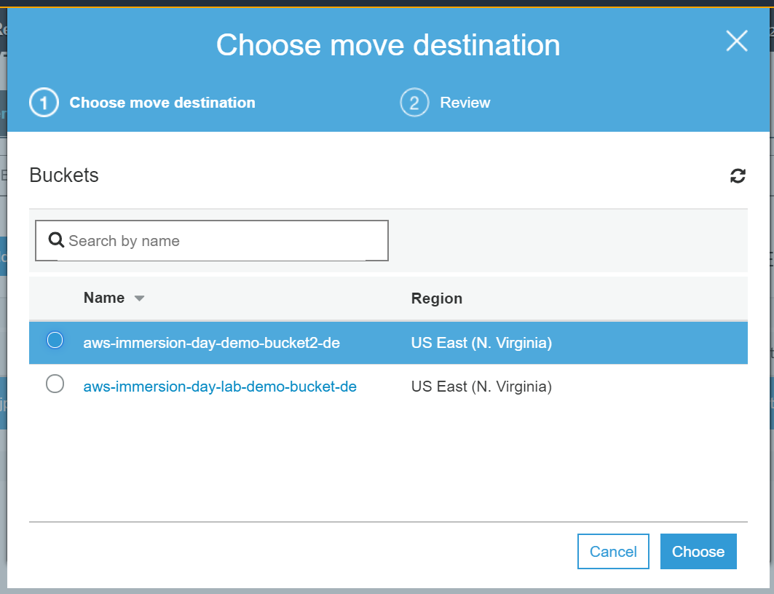Select the location to which you want to move the object. Then Select Choose. Verify the information is correct. Then select Move.

You can verify that you original bucket is now empty. The file will be in the new bucket.

**Congratulations - you have now moved an object between buckets.**

# Enable Bucket Versioning

If you want to add new version of the object to the same bucket but want to retain the old version, you can turn on bucket versioning.

1. In the S3 Console, click on the bucket name. Then select the **Properties** tab.
2. 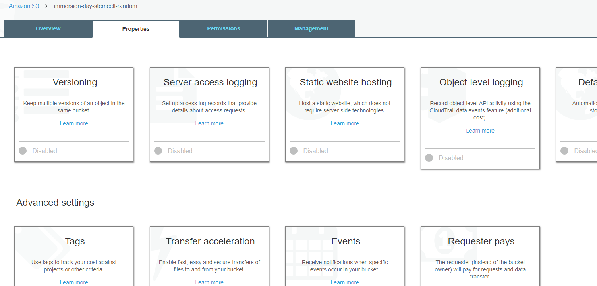Click on the **Versioning** tile, select the **Enable versioning** radio button, and then click **Save**.
3. Choose an object that you are able to edit on your computer, and upload it using the steps from the **Add an Object to a Bucket** section above.
4. Now open the original file on your computer and edit it, saving the updated version under the **same file name**.
5. Upload this updated file to the S3 bucket in the same way as before.
6. 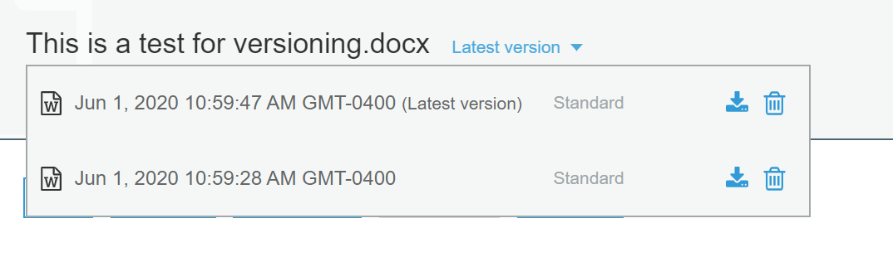Now click on the object’s link in the S3 bucket and click on the words **Latest version** (to the right of the object’s name).

This shows the different versions of the object in the bucket. You can click on the **download** icon next to each version of the object to download that version.

**Well done - you have now uploaded 2 different version of the same document.**

# Delete an Object and Bucket

You have added an object to a bucket, viewed it, and moved it. Now, you can delete it and the bucket it is in. If you no longer need to store the objects you uploaded and moved while going through this guide, you should delete them so you do not incur further charges on those objects.

1. In the Amazon S3 console, click on the link representing the bucket containing the object(s) you want to delete. Then select the checkboxes for the object(s) you would like to delete.
2. Click the **Actions** button. Then select **Delete**. To confirm the action in the **Delete objects** dialogue, click **Delete**.

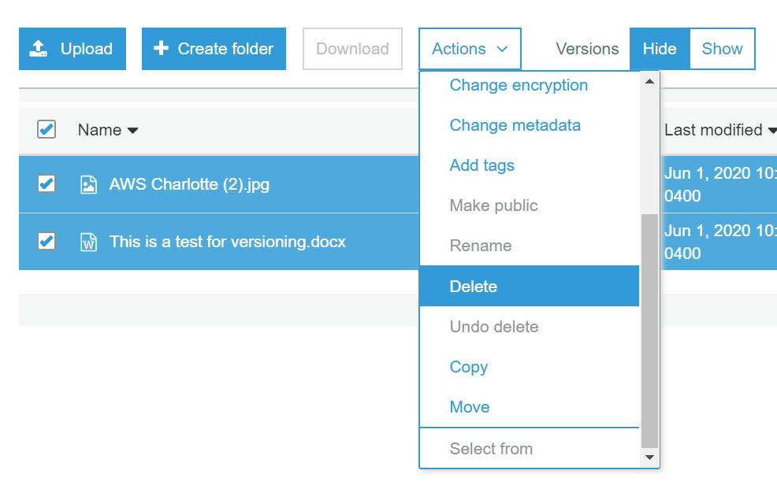

1. If you deleted one or more objects from a bucket in which versioning is enabled, select the **Show** option next to **Versions** to see that the older versions of the deleted objects still exist.

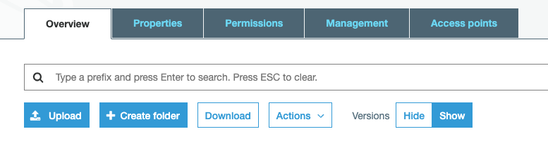

1. You can then select the checkboxes for the older versions of the objects, click **Actions** and then **Delete** to delete the older versions.
2. 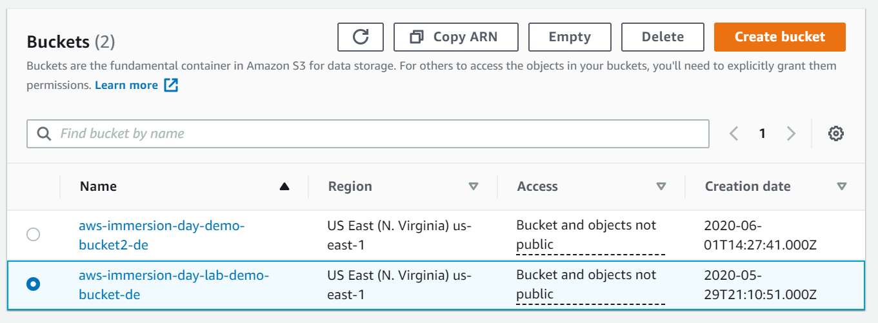Navigate back to the S3 console and select the bucket icon of the bucket you want to delete (not the link to its right), and at the top of the page, click **Delete**. Confirm the deletion by typing its name verbatim at the **Delete bucket** prompt.

**Well done, your bucket is now deleted!**

# Conclusion

In this lab you have learned the basic operations to manage the lifecycle of an S3 object. First, you created a bucket, which is the logical container of objects. Then by uploading, viewing, moving an object, and enabling versioning, you learned the basic operations of the object itself. Finally, you learned how to delete both an object and a bucket.

You can also access S3 from the AWS CLI or the API

[Click here for CLI Information](https://docs.aws.amazon.com/cli/latest/userguide/cli-services-s3.html)

[Click here for API information](https://docs.aws.amazon.com/AmazonS3/latest/API/Welcome.html)

You should continue exploring more features of S3!

* Did you know you can host a website entirely on S3?
* Did you know you can define automated lifecycle policies?
* How about fine-grained access control with Bucket Policy?